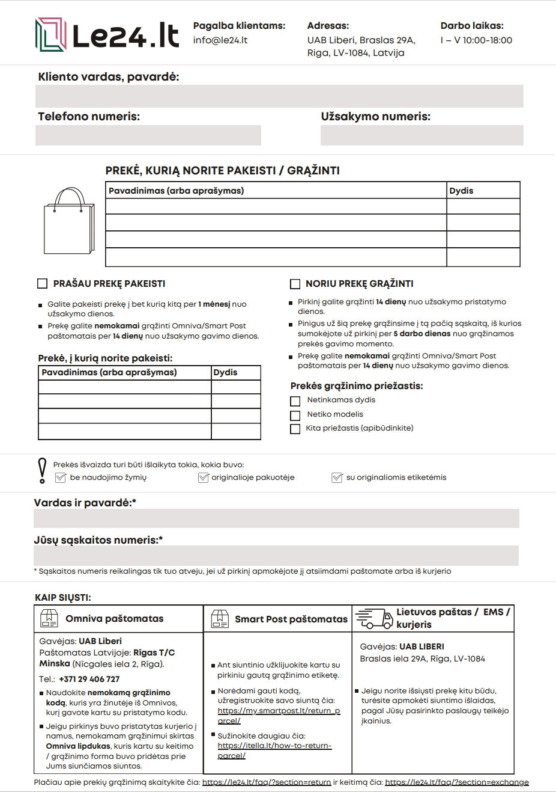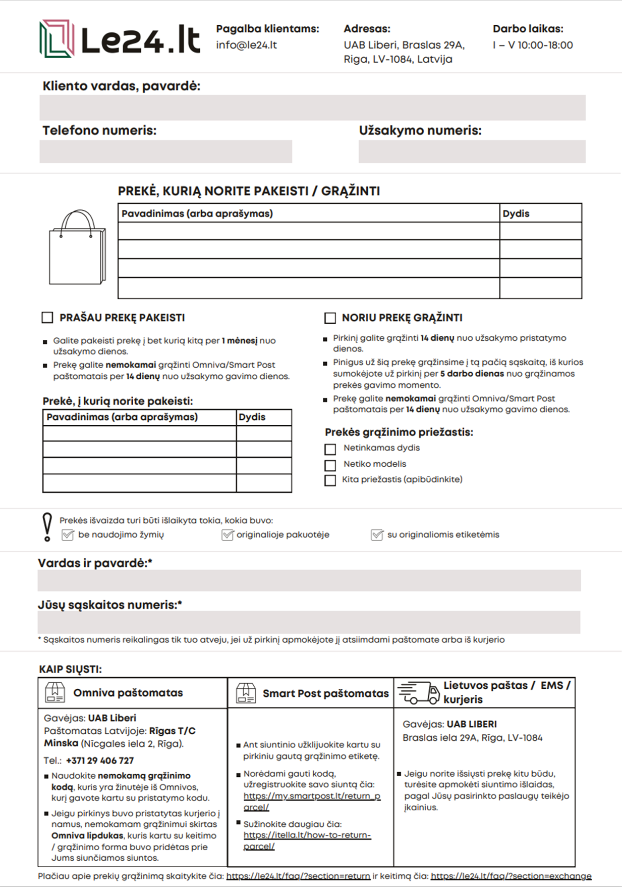

<https://le24.lt/faq/?section=return>

<https://le24.lt/faq/?section=exchange>

<https://my.smartpost.lt/return_parcel>

<https://itella.lt/how-to-return-parcel/>

