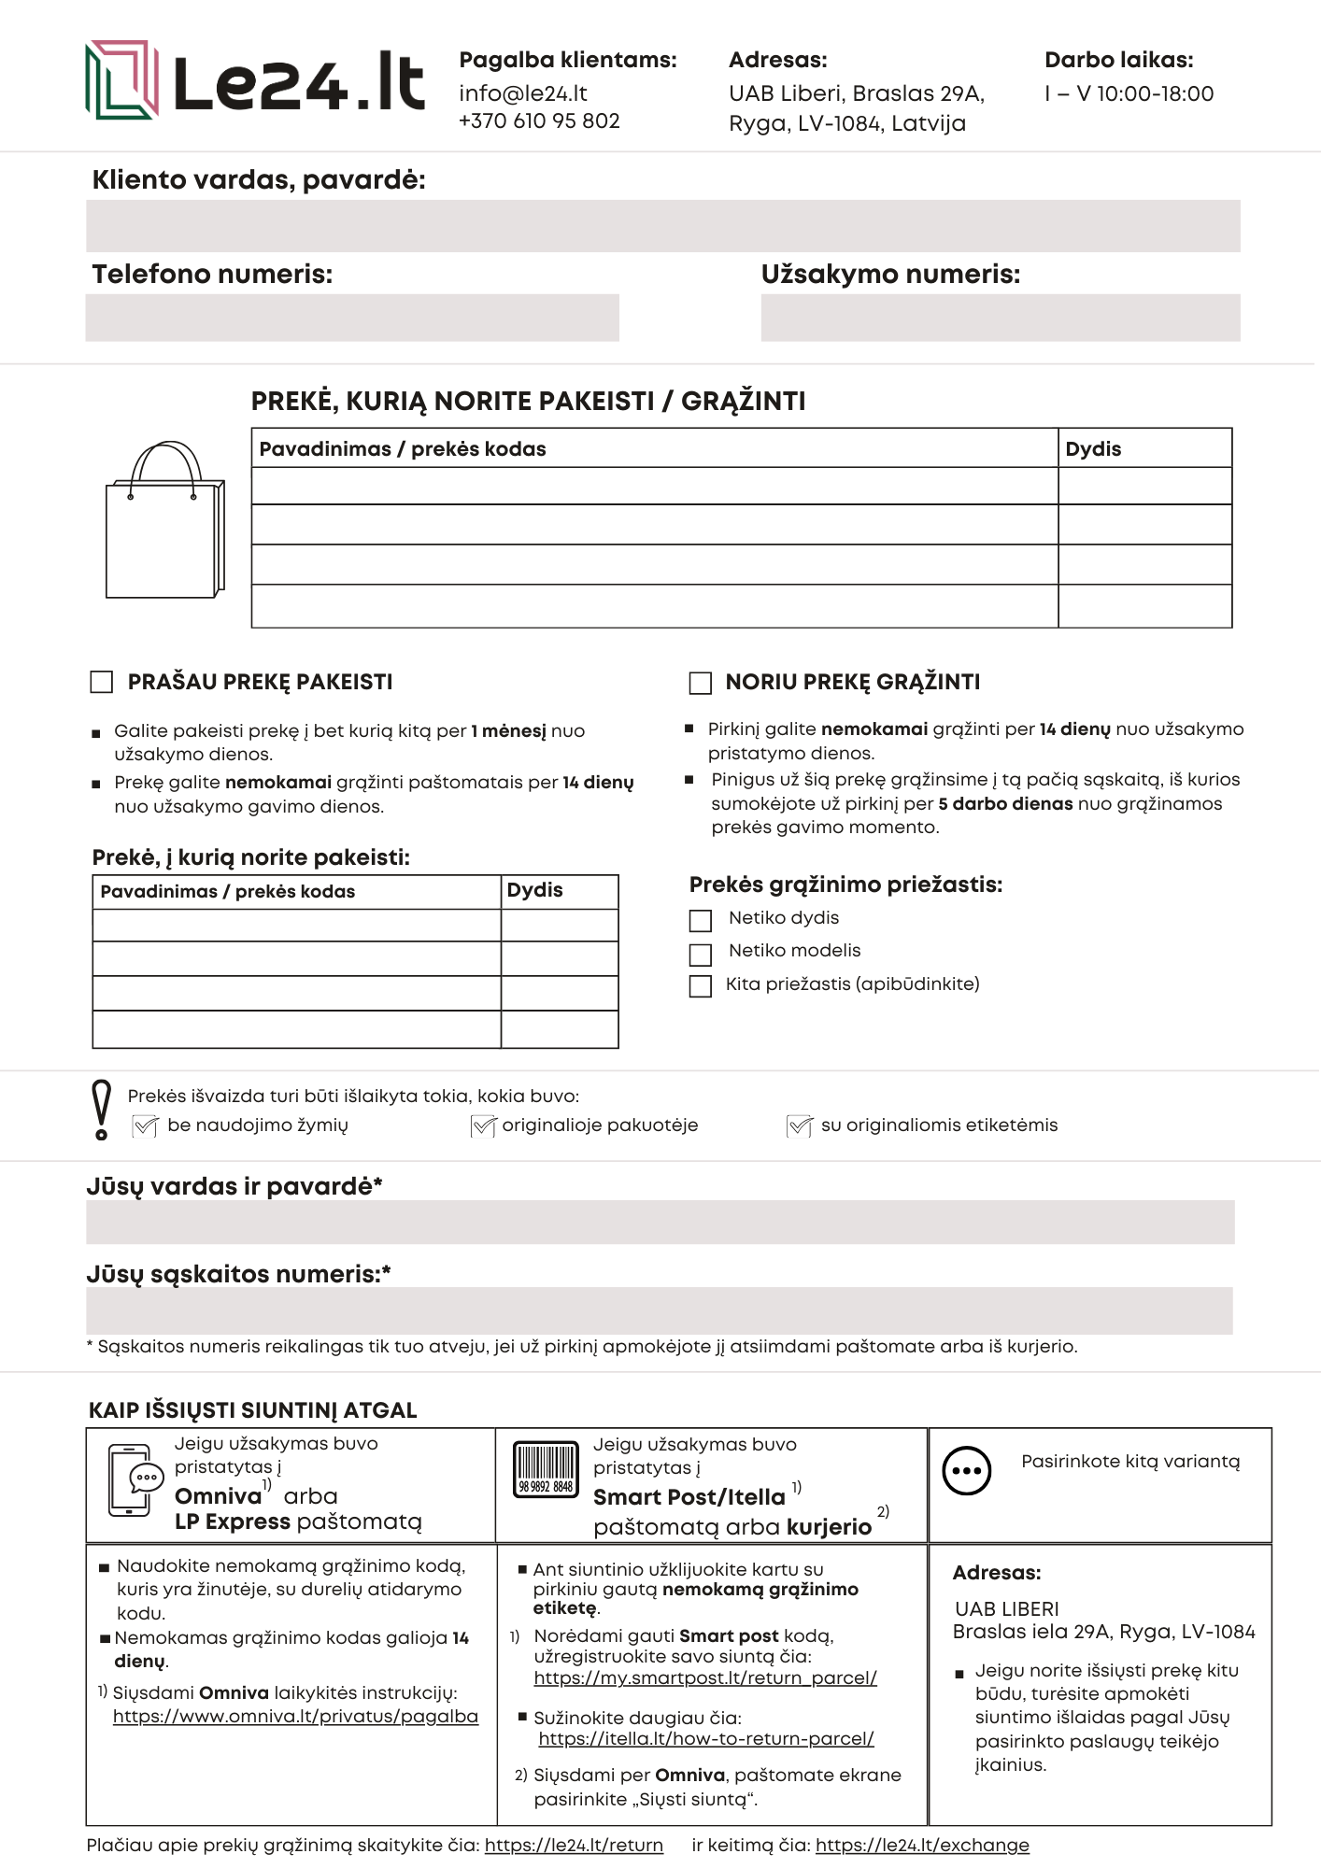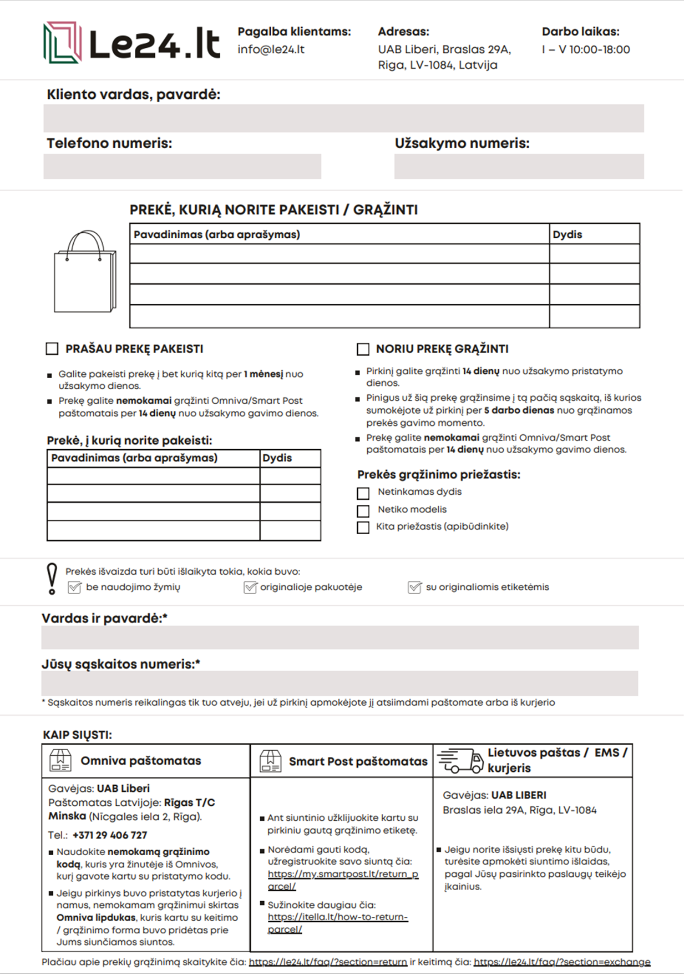

<https://www.omniva.lt/privatus/pagalba>

<https://le24.lt/exchange>

<https://itella.lt/how-to-return-parcel/>

<https://my.smartpost.lt/return_parcel>

<https://le24.lt/return>